***A***

***PROJECT REPORT***

*on*

## ORDER BOOK - INVOICE GENERATOR

*Submitted in partial fulfillment of the requirements for the degree of*

## BACHELOR OF TECHNOLOGY



**Session: - Jan-June 2024**

**Under Guidance of Submitted by**

Mr. Aditya Maheshwari Nishant Sharma (20ETCCS080)

Head - Industry Projects Pranjul Singh (20ETCCS088) Dept. of CSE TINJRIT, Udaipur Gunreet Kaur (20ETCCS044)

Aryaman Vyas (20ETCCS012)

Shakti Raj Singh (21ETCCS200)

Himanshi Jain (20ETCCS050)

## VIII Sem, Computer Science

**DEPARTMENT OF COMPUTER SCIENCE AND ENGINEERING TECHNO INDIA NJR INSTITUTE OF TECHNOLOGY, UDAIPUR-313001**

## MAY - 2024

a



Department of Computer Science and Engineering Techno India NJR Institute of Technology, Udaipur-313001

# Certificate

This is to certify that project work titled “**ORDER BOOK - INVOICE GENERATOR”** by

## PRANJUL SINGH, NISHANT SHARMA, GUNREET KAUR, SHAKTI RAJ SINGH ,

**ARYAMAN VYAS, Himanshi Jain** was successfully carried out in the Department of Computer Science and Engineering, TINJRIT and the report is approved for submission in the partial fulfillment of the requirements for the award of degree of Bachelor of Technology in Computer Science and Engineering.

**Mr. Aditya Maheshwari Dr. Rimpy Bishnoi**

Head - Industry Projects Head of Department Dept. of CSE TINJRIT, Udaipur Dept. of CSE TINJRIT, Udaipur

Date: 11/05/2024 Date: 11/05/2024



Department of Computer Science and Engineering Techno India NJR Institute of Technology, Udaipur-313001

# Examiner Certificate

This is to certify that the following student

**NISHANT SHARMA, PRANJUL SINGH, GUNREET KAUR, ARYAMAN VYAS ,SHAKTI RAJ SINGH, HIMANSHI JAIN** of final year B.Tech. (Computer Science and Engineering), was examined for the project work titled

***“ORDER BOOK - INVOICE GENERATOR”***

during the academic year 2024 – 2025 at Techno India NJR Institute of Technology, Udaipur.

## Remarks:

**Date:**

Signature Signature

(**Internal Examiner**) (**External Examiner**) Name - Mr. Aditya Maheshwari Name - Dr. Rimpy Bisnoi

Designation - Head-Industry Projects Designation - Head of Department

Department - CSE TINJRIT, Udaipur Department - CSE TINJRIT, Udaipur Organization - TINJRIT Organization - TINJRIT

# PREFACE

The development of the offline invoice generator project using Room Database in Android Kotlin marks a significant milestone in addressing the challenges faced by small businesses and shopkeepers in generating invoices. This project aims to provide a user-friendly and efficient solution that enables offline invoice generation, particularly for individuals who may have limited access to the internet or lack technical expertise in using online invoicing systems.

The preface serves as an introduction to the report, providing an overview of the project's background, objectives, and the organization of the following chapters. It sets the context for understanding the significance of the offline invoice generator project and its potential impact on improving the invoicing process for small businesses.

In this preface, we will provide a brief description of each of the ten chapters included in this report.

## Chapter 1: Introduction

The introduction chapter lays the foundation for the report, introducing the project's background, objectives, and scope. It highlights the significance of the offline invoice generator in addressing the challenges faced by small businesses and outlines the structure of the report.

## Chapter 2: Literature Review

In this chapter, we delve into the problem statement, discussing the current scenario of online invoice generation and the difficulties faced by small businesses. We emphasize the motivation behind developing an offline invoice generator that simplifies the process and caters to the needs of the target audience.

## Chapter 3: System Design

This chapter explores the system design and architecture of the offline invoice generator. It discusses the overall structure of the application, including the design patterns, architectural components, and the utilization of Room Database in Android Kotlin for data storage and retrieval.

## Chapter 4: Implementation

In this chapter, we provide in-depth insights into the implementation details of the offline invoice generator. We discuss the technical aspects, programming techniques, and best practices employed during the development process. It covers the integration of Room Database, implementation of key functionalities, and any challenges encountered during implementation.

## Chapter 5: Features and Functionality

The system requirements and analysis chapter focuses on identifying and analyzing the requirements of the offline invoice generator. It includes a detailed examination of the functionalities, features, and constraints to ensure that the application meets the expectations and needs of the users.

## Chapter 6: User Experience and Interface Design

The user experience and interface design chapter focus on creating a seamless and intuitive user interface for the offline invoice generator. It covers the design principles, user interface components, and navigation flows implemented to ensure a user-friendly and visually appealing experience for the target audience.

## Chapter 7: Performance Optimization

Performance optimization is a crucial aspect of any project that aims to deliver efficient and high-performing software or system. It involves identifying and addressing bottlenecks and inefficiencies to improve the overall performance and responsiveness of the project. In a project report, it is essential to highlight the steps taken and techniques employed for performance optimization to showcase the project's effectiveness.

## Chapter 8: Testing and Quality Assurance

The testing and quality assurance chapter highlights the importance of thorough testing to ensure the reliability and functionality of the offline invoice generator. It discusses the different types of testing conducted, such as unit testing, integration testing, and system testing. Additionally, it emphasizes the significance of quality assurance processes in maintaining the application's overall quality.

## Chapter 9: Deployment and Maintenance

In this chapter, we delve into the deployment process of the offline invoice generator. It covers the steps involved in preparing the application for deployment, release management strategies, user support and maintenance practices, and data backup and recovery mechanisms. It also explores the monitoring and analytics tools utilized for maintaining and improving the application over time.

## Chapter 10: Conclusion

The conclusion chapter provides a comprehensive summary of the offline invoice generator project. It summarizes the key aspects discussed in each chapter, evaluates the project's success in meeting its objectives, and suggests potential areas for future improvements and enhancements.

## Appendices

The appendices section includes supplementary information to support the main chapters of the report. It includes a glossary of terms, database schema, code snippets, user manual, test cases, and sample invoices. These appendices provide additional resources for readers to gain a deeper understanding of the offline invoice generator project.

DEPARTMENT OF COMPUTER SCIENCE AND ENGINEERING TECHNO INDIA NJR INSTITUTE OF TECHNOLOGY, UDAIPUR-313001

# ACKNOWLEDGMENT

We take this opportunity to record our sincere thanks to all who helped us to successfully complete this work. Firstly, We are grateful to our **Supervisor MR. ADITYA MAHESHWARI** for his invaluable guidance and constant encouragement, support and most importantly for giving us the opportunity to carry out this work.

We would like to express our deepest sense of gratitude and humble regards to our

**Head of Department DR. RIMPY BISHNOI** for giving invariable encouragement in our endeavors and providing necessary facilities for the same. Also a sincere thanks to all faculty members of CSE, TINJRIT for their help in the project directly or indirectly.

Finally, we would like to thank my friends for their support and discussions that have proved very valuable for us. We are indebted to our parents for providing constant support, love and encouragement. We thank them for the sacrifices they made so that we could grow up in a learning environment. They have always stood by us in everything we have done, providing constant support, encouragement and love.

**Nishant Sharma (20ETCCS080)**

**Pranjul Singh (20ETCCS088)**

**Gunreet Kaur (20ETCCS044)**

**Aryaman Vyas (20ETCCS012)**

**Shakti raj singh (21ETCCS200)**

**Himanshi Jain (20ETCCS050)**

DEPARTMENT OF COMPUTER SCIENCE AND ENGINEERING TECHNO INDIA NJR INSTITUTE OF TECHNOLOGY, UDAIPUR-313001

# CONTENTS

|  |  |
| --- | --- |
| **Abstract………………………………………………………………………………** | i |
| **Contents……………………………………………………………………………..** | ii-iv |
| **List of figures……………………………………………………………………….** | v |
| **Chapter 1: INTRODUCTION………………………………………………………** | **1** |
| 1.1 Background………………………………………………………… | 1 |
| 1.2 Problem Statement……………………………………………….. | 1 |
| 1.3 Objective…………………………………………………………… | 1 |
| 1.4 Scope of the Project……………………………………………… | 1 |
| **Chapter 2: LITERATURE REVIEW………………………………………………** | **2-3** |
| 2.1 Overview of Invoice Generation Systems……………………… | 2 |
| 2.2 Existing Solutions and Limitations……………………………… | 2 |
| 2.3 Relevant Technologies and Tools………………………………. | 2 |
| 2.4 Summary………………………………………………………….. | 3 |
| **Chapter 3: SYSTEM DESIGN…………………………………………………….** | **4-6** |
| 3.1 System Architecture……………………………………………… | 4 |
| 3.2 Use Case Diagram……………………………………………….. | 4 |
| 3.3 Class Diagram……………………………………………………. | 4 |
| 3.4 Database Schema Design………………………………………. | 5 |
| 3.5 Summary………………………………………………………….. | 6 |
| **Chapter 4: IMPLEMENTATION……………………………………………………** | **7-9** |
| 4.1 Development Environment Setup…………………………….. | 7 |
| 4.2 User Interface Design………………………………………….. | 7 |
| 4.3 Room Database Integration…………………………………… | 7 |

* 1. Invoice Generation Logic……………………………………… 8
  2. Testing and Debugging………………………………………… 8

4.6 Summary………………………………………………………. 9

Chapter 5: FEATURES AND FUNCTIONALITY…………………………….. 10-13

* 1. User Registration and Login………………………………….. 10
  2. Dashboard and Navigation……………………………………. 11

5.3 Customer Management……………………………………….. 11

5.4 Product Management…………………………………………. 12

* 1. Invoice Creation and Editing…………………………………. 12
  2. Invoice History and Tracking…………………………………. 13

5.7 Summary………………………………………………………… 13

Chapter 6: USER EXPERIENCE AND INTERFACE DESIGN..…………… 14-15

* 1. Importance of User Experience (UX)………………………….. 14
  2. Interface Design Principles……………………………………. 14
  3. Visual Design Elements…..…………………………………… 14
  4. Mobile-Friendly Design………………………………………… 14
  5. Usability Testing and Iteration…………………………………. 15

6.6 Summary………………………………………………………… 15

Chapter 7: PERFORMANCE OPTIMIZATION……………………………… 16-18

7.1 Importance of Performance Optimization…………………… 16

7.2 Code Optimization…………………………………………….. 16

* 1. Database Performance Optimization……………………….. 16
  2. Network and Data Synchronization Optimization…………… 17
  3. UI and Rendering Optimization……………………………… 17
  4. Performance Profiling and Monitoring………………………. 17

7.7 Summary……………………………………………………….. 17

Chapter 8: TESTING AND QUALITY ASSURANCE………………………… 19-21

* 1. Importance of Testing and Quality Assurance………………. 19
  2. Test Planning and Strategy……………………………………. 19

8.3 Unit Testing……………………………………………………… 19

8.4 Integration Testing.……………………………………………… 19

8.5 System Testing…………………………………………………. 20

8.6 Performance Testing…………………………………………… 20

8.7 Quality Assurance and Bug Tracking………………………… 20

8.8 Summary………………………………………………………… 20

Chapter 9: DEPLOYMENT & MAINTENANCE……………………………… 22-23

9.1 Deployment Process………………………….……………… 22

9.2 Release Management…………..…………………………….. 22

* 1. User Support and Maintenance……………………………… 22
  2. Data Backup and Recovery………………………………….. 22
  3. Monitoring and Analytics……………………………………… 23
  4. Continuous Improvement…………………………………….. 23

9.7 Summary……………………………………………………….. 23

Chapter 10: CONCLUSION…………………………………………………… 24

10.1 Project Summary…………………………………………… 24

10.2 Project Evaluation…………….……………………………. 24

10.3 Future Work……..………………………………………….. 24

10.4 Conclusion………………………………………………….. 24

Chapter 11: APPENDICES…………………………………………………… 25-28

A: Glossary…………….………………………………………… 25

B: Database Schema Diagram………………………………… 25

C: Code Snippets………………………………………………… 26

D: User Manual………..…………………………………………. 27

E: Test Cases…………………………………………………….. 27

F: Sample Invoices………………………………………………. 28

**LIST OF FIGURES**

|  |  |  |
| --- | --- | --- |
| Fig 4-1: | Database Schema...…………………………………………… | 8 |
| Fig 5-1: | Splash Screen…………………………………………………… | 10 |
| Fig 5-2: | Set up Profile Screen…………………………………………… | 10 |
| Fig 5-3: | Logo’s Screen…………………………………………………… | 10 |
| Fig 5-4: | Home Screen……………………………………………………. | 11 |
| Fig 5-5: | Create Invoice Screen………………………………………….. | 12 |
| Fig 5-6: | Add Item Screen………………………………………………… | 12 |
| Fig 11-1: DB Schema…………………………………………………….. | | 25 |
| Fig 11-2: Dao Class………………………………………………………. | | 26 |

Fig 11-3: Database Initialization Class………………………………….. 27

Fig 11-4 Sample Invoice 1……………………………………………….. 28

Fig 11-5 Sample Invoice 2……………………………………………….. 28

# CHAPTER - 1 INTRODUCTION

## Background

In this chapter, we provide an overview of the project by introducing the background and context in which it is developed. We discuss the importance of invoice generation systems in various industries and the need for an offline solution using Room Database in Android Kotlin.

## Problem Statement

This section highlights the problem statement that the project aims to address. It emphasizes the limitations of existing online invoice generators and the challenges faced when internet connectivity is not available. The focus is on developing an efficient and user-friendly offline invoice generator.

## Objective

The objectives of the project are defined in this section. We outline the main goals, including the development of an offline invoice generator using Room Database in Android Kotlin. The objectives may include features such as user registration, invoice creation and editing, customer and product management, and a seamless user experience.

## Scope of the Project

Here, we discuss the scope of the project, outlining the boundaries within which the development and implementation will take place. This includes specifying the target platform (Android) and the technologies to be used (Room Database, Kotlin). The scope may also cover the intended user base, any potential limitations, and the expected outcomes of the project.

# CHAPTER - 2 LITERATURE REVIEW

## Overview of Invoice Generation Systems

This section provides an overview of existing invoice generation systems available in the market. It discusses the different types of systems, such as online and offline solutions, and their features and functionalities. The focus is on understanding the current landscape of invoice generation systems and the benefits they offer to businesses.

## Existing Solutions and Limitations

Here, we explore the limitations of current invoice generation systems, particularly those that are online-based. We highlight the challenges faced by shopkeepers who may not be technologically proficient or have reliable internet access. These limitations may include complex user interfaces, slow processing times, and dependence on internet connectivity, making it difficult for less-educated shopkeepers to create invoices efficiently.

## Relevant Technologies and Tools

In this section, we discuss the relevant technologies and tools that can be used to develop an offline invoice generator. Specifically, we focus on the Room Database, a powerful and efficient database library for Android, and Kotlin, a modern programming language that simplifies Android app development. We explain how these technologies can address the limitations of existing systems and provide a user-friendly solution for shopkeepers.

## Summary

The literature review chapter concludes by summarizing the key findings from the review of existing invoice generation systems. It highlights the shortcomings of online solutions and emphasizes the need for an offline-based invoice generator to cater to the

requirements of less-educated shopkeepers. Furthermore, it introduces the Room Database and Kotlin as suitable technologies for developing such a solution.

# CHAPTER - 3 SYSTEM DESIGN

## System Architecture

In this section, we discuss the overall system architecture of the offline invoice generator using Room Database in Android Kotlin. We explain the high-level structure and components of the system, including the client-side (Android application) and the database layer. The architecture may follow a modular design pattern, such as Model-View-ViewModel (MVVM) or Model-View-Presenter (MVP), to ensure separation of concerns and maintainability.

## Use Case Diagram

A use case diagram is presented to illustrate the various interactions between actors (e.g., shopkeepers) and the system. It depicts the main functionalities and actions that can be performed within the offline invoice generator. This includes activities such as user registration, invoice creation, editing invoices, managing customers, and managing products. The diagram provides a visual representation of the system's behavior from a user's perspective.

## Class Diagram

A class diagram is provided to illustrate the class relationships and dependencies within the system. This diagram showcases the key classes and their attributes and methods. In the context of the offline invoice generator, the class diagram may include classes such as UserProfile (representing the businessman's profile), InvoiceItem (representing the details of purchased items), and other relevant classes for data handling and business logic.

## Database Schema Design

The database schema design is crucial for efficiently storing and retrieving data in the offline invoice generator. In this section, we present three schemas that are essential for the system's functioning.

## Profile Table Schema

The profile_table schema represents the information related to the businessman's profile. It includes attributes such as:

* + - * Company Name: The name of the businessman's company.
      * User Name: The name of the businessman.
      * Email: The email address of the businessman.
      * Contact Number: The contact number of the businessman.
      * Address: The address of the businessman's company.
      * Company Logo: The logo of the businessman's company.
      * GST Number: The Goods and Services (GST) number associated with the company.
      * Signature Icon: The digital signature icon of the businessman.

## Invoice Items Table Schema

The invoice_items schema represents the details of purchased items in an invoice. It includes attributes such as:

* + - * Item Name: The name of the purchased item.
      * Quantity: The quantity of the purchased item.
      * SGST: The State Goods and Services Tax (SGST) applicable to the item.
      * CGST: The Central Goods and Services Tax (CGST) applicable to the item.
      * IGST: The Integrated Goods and Services Tax (IGST) applicable to the item.
      * Price: The price of a single unit of the item.
      * Total Price: The total price of the purchased item.

## Summary

This section summarizes the system design, including the system architecture, use case diagram, class diagram, and database schema design. It provides an overview of the overall structure and components of the offline invoice generator using Room Database in Android Kotlin. The design ensures a clear understanding of how different parts of the system interact and function together.

# CHAPTER - 4 IMPLEMENTATION

## Development Environment Setup

In this section, we provide a detailed explanation of the development environment setup required to build the offline invoice generator using Room Database in Android Kotlin. We discuss the necessary software and tools, including Android Studio, Kotlin plugin, and Room Database library. Step-by-step instructions are provided for installing and configuring the development environment, ensuring that readers can follow along and set up their own development environment.

## User Interface Design

User interface (UI) design plays a crucial role in creating a user-friendly and intuitive experience for the shopkeepers using the offline invoice generator. In this section, we describe the UI design process, including wireframing, prototyping, and creating the final UI elements. We discuss the design principles considered, such as simplicity, clarity, and consistency, and how they are applied to ensure an intuitive and visually appealing interface.

## Room Database Integration

Room Database is a powerful library provided by Android for data persistence. In this section, we explain the process of integrating Room Database into the offline invoice generator. We discuss the creation of the necessary entities, data access objects (DAOs), and the database itself. We also cover the implementation of CRUD (Create, Read, Update, Delete) operations, ensuring that the businessman's profile and invoice items can be stored, retrieved, updated, and deleted effectively.

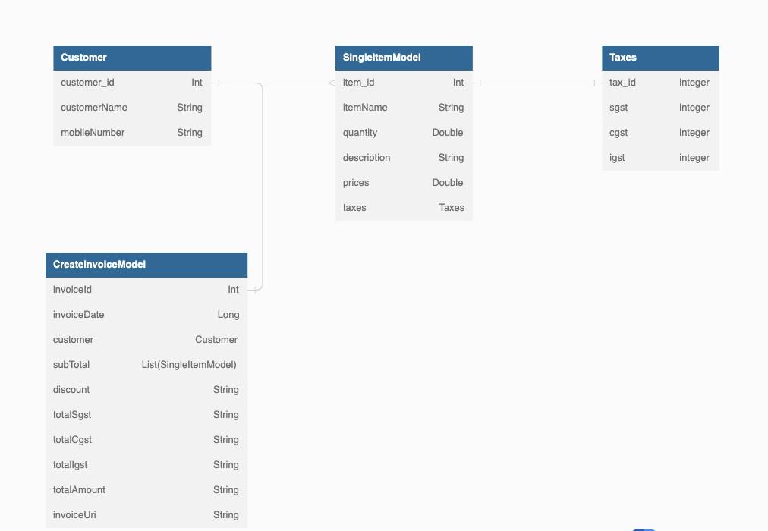

Fig 4-1: Database Schema

## Invoice Generation Logic

The heart of the offline invoice generator lies in its ability to generate invoices accurately and efficiently. In this section, we delve into the implementation of the invoice generation logic. We explain the algorithm for calculating taxes (SGST, CGST, IGST), generating itemized lists, and calculating the total price. We also discuss any additional features, such as discounts or promotions, that may be implemented in the invoice generation process.

## Testing and Debugging

Thorough testing and debugging are essential to ensure the reliability and stability of the offline invoice generator. In this section, we describe the testing process, including unit testing, integration testing, and user acceptance testing. We discuss the tools and

frameworks used for testing and demonstrate how various scenarios and edge cases are tested. Additionally, we explain the debugging techniques employed to identify and fix any issues or bugs encountered during the development process.

## Summary

The implementation chapter concludes with a summary of the development process for the offline invoice generator. We reflect on the setup of the development environment, the UI design considerations, the integration of Room Database, the implementation of the invoice generation logic, and the testing and debugging efforts. This summary serves as a recap of the key implementation aspects covered in the chapter.

# CHAPTER - 5 FEATURES & FUNCTIONALITY

## User Registration and Login

The offline invoice generator includes a user registration and login system to ensure secure access to the application. In this section, we describe the user registration process, where shopkeepers can create an account by providing their relevant details such as name, email, and contact number. We also discuss the login functionality, which allows registered users to securely log in to the application using their credentials.

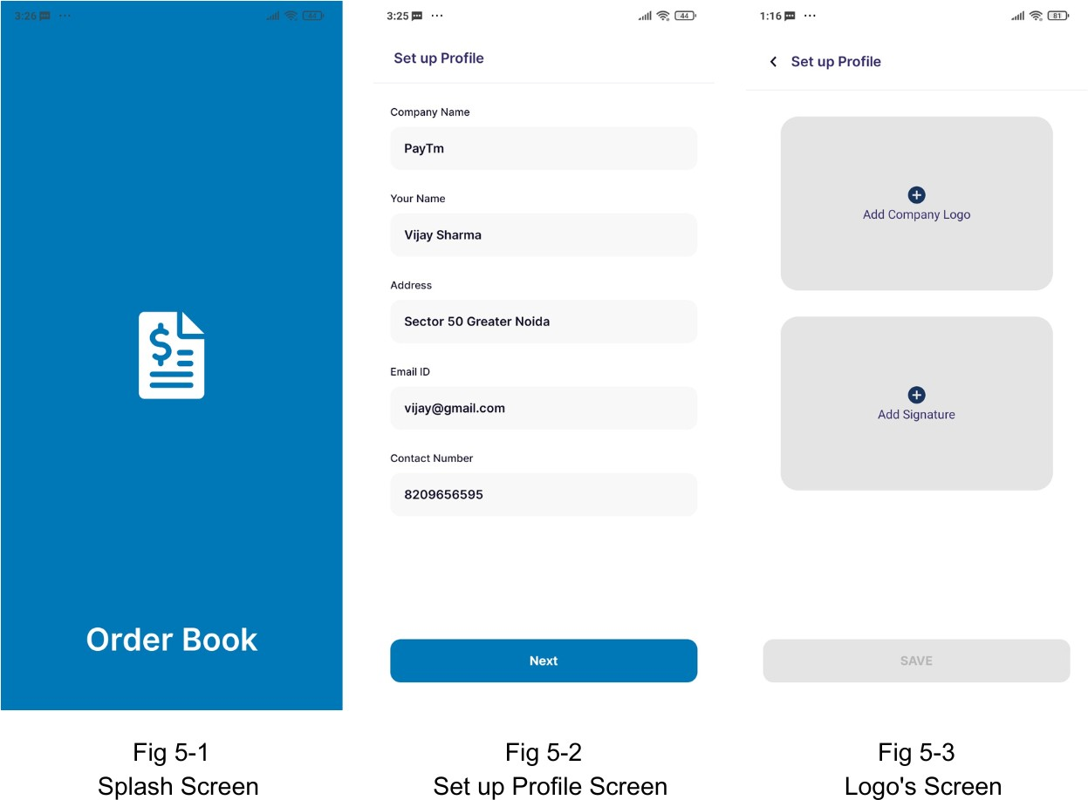

## Dashboard and Navigation

The dashboard serves as the main hub of the offline invoice generator, providing an overview of key information and access to various features. In this section, we explain the design and functionality of the dashboard, which may include displaying statistics, notifications, and quick access to important sections such as creating invoices, managing customers, and managing products. We also discuss the navigation system, ensuring smooth transitions between different screens and sections of the application.

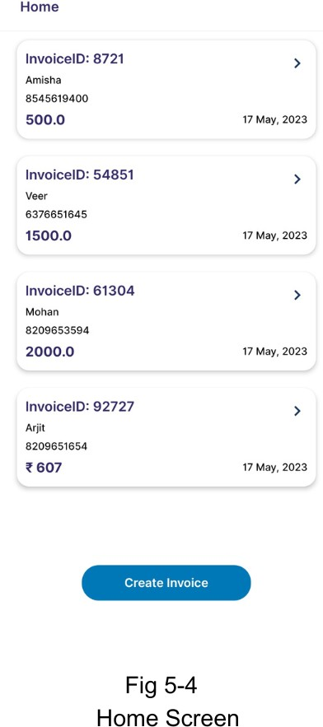

## Customer Management

Efficient customer management is vital for generating accurate invoices. In this section, we discuss the functionality of the customer management module. Shopkeepers can add new customers by entering their details, such as name, contact information, and address. The system should also allow for updating and deleting customer records. We emphasize the importance of maintaining a well-organized customer database for quick and easy access when generating invoices.

## Product Management

Effective product management is essential for accurate invoice generation and inventory tracking. In this section, we outline the functionality of the product management module. Shopkeepers can add new products, including details such as name, description, price, and tax rates. The system should also allow for updating and deleting product records. Additionally, we discuss the importance of maintaining an up-to-date product inventory for seamless invoice generation.

## Invoice Creation and Editing

The core functionality of the offline invoice generator lies in its ability to create and edit invoices. In this section, we explain how shopkeepers can create new invoices by selecting customers, adding purchased items, specifying quantities, and applying taxes. We also discuss the functionality for editing existing invoices, allowing for modifications such as adding or removing items, updating quantities, and recalculating prices. The aim is to provide a user-friendly interface and intuitive workflow for generating and editing invoices efficiently.

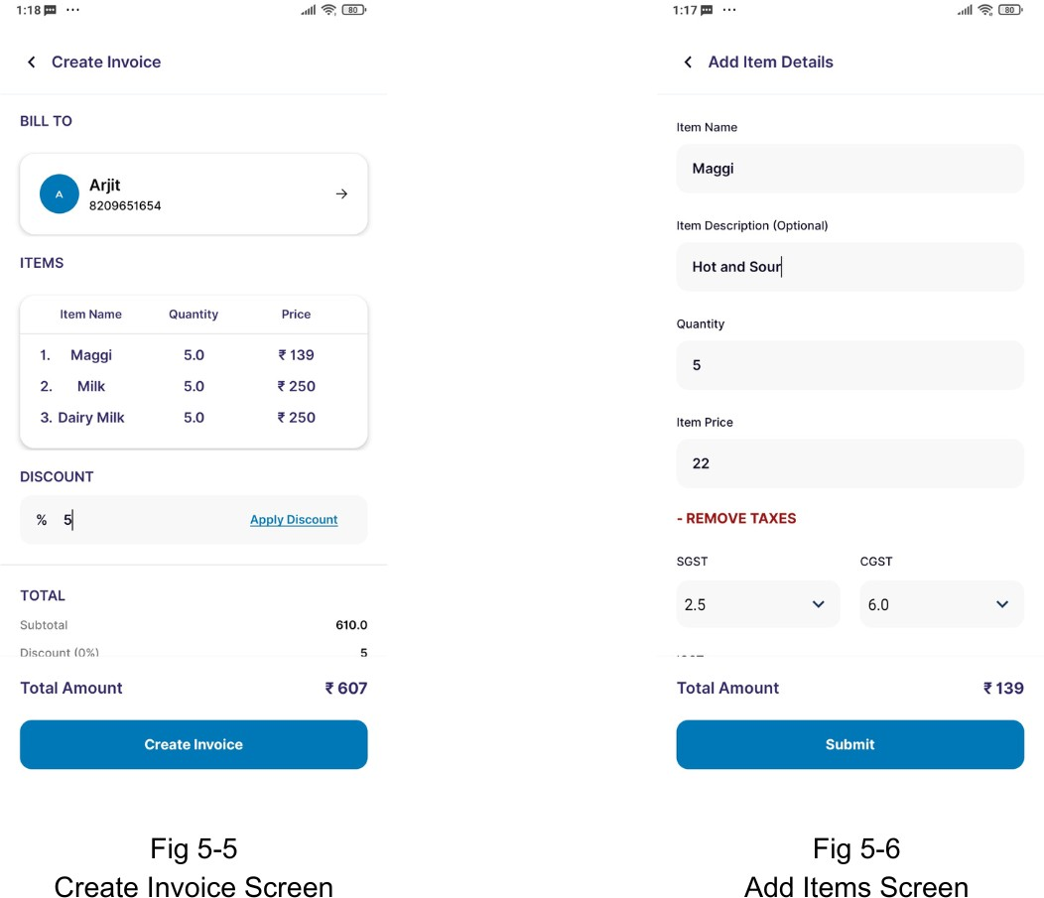

## Invoice History and Tracking

The offline invoice generator should maintain a record of generated invoices for easy reference and tracking. In this section, we describe the functionality for viewing invoice history, allowing shopkeepers to access and review past invoices. The system may provide search and filtering options based on various criteria such as customer name, date, or invoice number. We also discuss the importance of tracking invoice statuses, such as paid or unpaid, to facilitate better financial management.

## Summary

The features and functionality chapter concludes with a summary of the key features provided by the offline invoice generator. We recap the user registration and login process, the dashboard and navigation system, customer management, product management, invoice creation and editing, and invoice history and tracking. This summary serves as a comprehensive overview of the application's capabilities.

# CHAPTER - 6

**USER EXPERIENCE AND INTERFACE DESIGN**

## Importance of User Experience (UX)

User experience plays a critical role in the success of any application. In this section, we discuss the importance of providing a seamless and intuitive user experience in the offline invoice generator. We highlight the benefits of a well-designed user interface, such as increased productivity, user satisfaction, and reduced learning curve for less-educated shopkeepers. Emphasizing the importance of UX sets the foundation for the subsequent sections on interface design.

## Interface Design Principles

In this section, we explore the fundamental principles of interface design that contribute to a positive user experience. We discuss principles such as simplicity, consistency, visibility, and feedback. We explain how these principles guide the design of the offline invoice generator's interface, ensuring ease of use and minimizing user errors. By adhering to these principles, the application can provide a user-friendly and intuitive experience to shopkeepers.

## Visual Design Elements

Visual design elements play a crucial role in enhancing the aesthetics and usability of the offline invoice generator. In this section, we discuss various visual design elements, such as color schemes, typography, icons, and layout. We explain how the appropriate use of these elements can create a visually appealing and cohesive interface that aligns with the branding and purpose of the application. We also consider the importance of readability, contrast, and accessibility in visual design.

## Mobile-Friendly Design

As the offline invoice generator is developed for Android devices, it is essential to consider mobile-friendly design principles. In this section, we discuss the considerations for designing interfaces that are optimized for mobile devices. This includes responsive

design, touch-friendly elements, and adapting to different screen sizes and resolutions. We also address the importance of performance optimization to ensure smooth and responsive interactions on mobile devices.

## Usability Testing and Iteration

Usability testing is crucial in evaluating and improving the user experience of the offline invoice generator. In this section, we discuss the process of conducting usability tests with real users. We explain the importance of gathering feedback, identifying usability issues, and iterating on the design based on user insights. We also highlight the significance of incorporating user feedback throughout the development process to continually refine and enhance the application's usability.

## Summary

The user experience and interface design chapter concludes with a summary of the key aspects discussed. We emphasize the importance of providing a seamless and intuitive user experience in the offline invoice generator. We discuss the principles of interface design, the use of visual design elements, the considerations for mobile-friendly design, and the significance of usability testing and iteration. This summary provides a comprehensive overview of the focus on user experience and interface design in the application.

# CHAPTER - 7 PERFORMANCE OPTIMIZATION

## Importance of Performance Optimization

In this section, we discuss the significance of performance optimization in the offline invoice generator. Efficient performance is crucial for providing a smooth and responsive user experience. We highlight the benefits of optimizing the application's performance, such as improved load times, reduced memory usage, and enhanced overall responsiveness. Emphasizing performance optimization sets the foundation for the subsequent sections on specific optimization techniques.

## Code Optimization

Code optimization plays a vital role in improving the performance of the offline invoice generator. In this section, we discuss various techniques for optimizing the codebase, such as minimizing redundant calculations, optimizing loops and conditionals, and reducing memory allocations. We also explore best practices for writing efficient and clean code, including proper resource management and avoiding unnecessary method calls. These optimizations can significantly enhance the application's performance and responsiveness.

## Database Performance Optimization

As the offline invoice generator utilizes Room Database, optimizing database performance is crucial for efficient data storage and retrieval. In this section, we discuss techniques for optimizing database operations, including efficient querying, indexing, and batch processing. We also explore strategies for managing database transactions effectively to ensure data consistency and minimize performance overhead. By optimizing the database operations, we can enhance the overall performance of the application.

## Network and Data Synchronization Optimization

Although the offline invoice generator primarily operates offline, it may have features that involve network connectivity or data synchronization. In this section, we discuss techniques for optimizing network operations, such as implementing caching mechanisms, compressing data transfers, and minimizing network requests. We also explore strategies for efficient data synchronization, including incremental updates and intelligent syncing algorithms. Optimizing network and data synchronization processes can enhance performance and minimize data transfer costs.

## UI and Rendering Optimization

Optimizing the user interface and rendering processes can significantly improve the perceived performance of the offline invoice generator. In this section, we discuss techniques for optimizing UI rendering, such as minimizing view hierarchy, leveraging view recycling, and using appropriate image formats and compression techniques. We also explore strategies for asynchronous loading of UI elements to ensure smooth and responsive interactions. These optimizations can create a seamless and fluid user interface experience.

## Performance Profiling and Monitoring

In this section, we discuss the importance of performance profiling and monitoring tools for identifying performance bottlenecks in the offline invoice generator. We explore tools and techniques for measuring and analyzing performance metrics, such as CPU and memory usage, database query execution time, and network latency. By leveraging these tools, developers can identify areas for optimization and continuously monitor the application's performance to ensure optimal user experience.

## Summary

The performance optimization chapter concludes with a summary of the key aspects discussed. We emphasize the importance of optimizing the offline invoice generator's performance to provide a smooth and responsive user experience. We discuss code optimization techniques, database performance optimization, network and data synchronization optimization, UI and rendering optimization, and the significance of

performance profiling and monitoring. This summary provides a comprehensive overview of the focus on performance optimization in the application.

# CHAPTER - 8

**TESTING AND QUALITY ASSURANCE**

## Importance of Testing and Quality Assurance

Testing and quality assurance are critical aspects of software development. In this section, we discuss the importance of testing the offline invoice generator thoroughly to ensure its functionality, reliability, and user satisfaction. We highlight the benefits of a robust testing process, including early bug detection, improved performance, and increased customer confidence. Emphasizing the significance of testing and quality assurance sets the foundation for the subsequent sections.

## Test Planning and Strategy

In this section, we explain the process of test planning and strategy for the offline invoice generator. We discuss the various types of testing that should be conducted, such as unit testing, integration testing, and system testing. We outline the steps involved in test planning, including identifying test objectives, defining test cases, and establishing test environments. Additionally, we discuss the importance of test documentation and tracking progress throughout the testing phase.

## Unit Testing

Unit testing focuses on testing individual components or units of the software in isolation. In this section, we describe the unit testing process for the offline invoice generator. We discuss the selection of test cases that cover different scenarios and functionalities of the application. We explore the use of testing frameworks and tools specific to Android Kotlin, such as JUnit and Mockito, to ensure comprehensive unit test coverage.

## Integration Testing

Integration testing verifies the interactions between different components and subsystems of the application. In this section, we explain the integration testing process for the offline invoice generator. We discuss the creation of test cases that focus on

testing the integration points between modules, ensuring proper communication and data flow. We explore techniques such as stubs and mocks to simulate dependencies and validate the integration of various components.

## System Testing

System testing validates the behavior and functionality of the complete system as a whole. In this section, we describe the system testing process for the offline invoice generator. We discuss the creation of test cases that cover end-to-end scenarios, including user interactions, data validation, and error handling. We also explore techniques such as black-box testing and user acceptance testing to ensure that the application meets the requirements and expectations of the end-users.

## Performance Testing

Performance testing evaluates the responsiveness and scalability of the offline invoice generator under different load conditions. In this section, we explain the performance testing process for the application. We discuss the selection of performance metrics, the creation of realistic test scenarios, and the use of tools such as JMeter or Firebase Performance Monitoring to measure and analyze the system's performance. We also explore techniques for identifying and resolving performance bottlenecks.

## Quality Assurance and Bug Tracking

Quality assurance involves monitoring and improving the overall quality of the software. In this section, we discuss the quality assurance process for the offline invoice generator. We explore techniques such as code reviews, static code analysis, and continuous integration to maintain code quality and detect potential issues early in the development cycle. Additionally, we emphasize the importance of bug tracking systems to capture, prioritize, and resolve issues identified during testing.

## Summary

The testing and quality assurance chapter concludes with a summary of the key aspects discussed. We highlight the importance of testing and quality assurance in ensuring the functionality, reliability, and user satisfaction of the offline invoice generator. We discuss the test planning and strategy, unit testing, integration testing, system testing,

performance testing, and quality assurance and bug tracking processes. This summary provides a comprehensive overview of the testing and quality assurance efforts in the development of the application.

# CHAPTER - 9 DEPLOYMENT & MAINTENANCE

## Deployment Process

In this section, we discuss the deployment process of the offline invoice generator. We outline the necessary steps to prepare the application for deployment, including code compilation, generating the APK (Android Package) file, and signing the application with the appropriate certificates. We also explore different deployment options, such as publishing the application on Google Play Store or distributing it directly to users.

## Release Management

Effective release management is crucial for a successful deployment. In this section, we discuss the process of managing releases for the offline invoice generator. We explore versioning strategies, such as semantic versioning, to ensure proper tracking and management of different software releases. We also discuss the importance of release notes and documentation to inform users about new features, bug fixes, and improvements in each release.

## User Support and Maintenance

Providing ongoing user support and maintenance is essential for the smooth operation of the offline invoice generator. In this section, we discuss the strategies for handling user support requests, such as setting up a support email or ticketing system. We also explore the importance of regularly updating the application to address bug fixes, security vulnerabilities, and compatibility issues with new Android versions. Additionally, we emphasize the significance of collecting user feedback and incorporating it into future updates.

## Data Backup and Recovery

Data backup and recovery mechanisms are critical to protect user data in case of any unforeseen events or data loss. In this section, we discuss the implementation of data backup and recovery strategies for the offline invoice generator. We explore options

such as local device backups, cloud storage integration, or synchronization with other devices. We also emphasize the importance of regularly testing the backup and recovery mechanisms to ensure their effectiveness.

## Monitoring and Analytics

Monitoring the performance and usage of the offline invoice generator is vital for identifying potential issues and making data-driven decisions. In this section, we discuss the implementation of monitoring and analytics tools for the application. We explore options such as crash reporting tools, user behavior tracking, and performance monitoring to gather insights on application usage, performance bottlenecks, and user engagement. This data can be used to optimize the application and improve user experience.

## Continuous Improvement

Continuous improvement is a key aspect of maintaining the offline invoice generator. In this section, we discuss the importance of continuous improvement in terms of adding new features, optimizing performance, and addressing user feedback. We explore agile development methodologies and the concept of iterative development to ensure a constant cycle of improvement. We also discuss the role of regular software updates in keeping the application up-to-date and meeting the evolving needs of users.

## Summary

The deployment and maintenance chapter concludes with a summary of the key aspects discussed. We highlight the deployment process, release management, user support and maintenance, data backup and recovery, monitoring and analytics, and continuous improvement efforts in the development and maintenance of the offline invoice generator. This summary provides a comprehensive overview of the deployment and maintenance processes involved in the application.

# CHAPTER - 10 CONCLUSION

## Summary of the Project

In this section, we provide a brief summary of the offline invoice generator project. We highlight the main objectives of the project, the features implemented, and the benefits of the application. We also discuss the technology stack used in the development process, including Android Kotlin and Room Database.

## Evaluation of the Project

In this section, we evaluate the offline invoice generator project in terms of its success in meeting the project objectives and requirements. We discuss the effectiveness of the application in addressing the challenges faced by small businesses in generating invoices and the impact of the application on improving their workflow and efficiency.

## Future Work

In this section, we outline the potential future work that could be done to improve and expand the functionality of the offline invoice generator application. We discuss possible features to add, such as integration with external accounting software, support for multiple languages and currencies, and synchronization with cloud storage platforms.

## Conclusion

The conclusion summarizes the key aspects of the project, including its objectives, features, benefits, and potential for future work. We emphasize the importance of the offline invoice generator application for small businesses, particularly those without access to reliable internet connectivity or technical expertise. We also highlight the significance of using modern development technologies, such as Android Kotlin and Room Database, to create robust and user-friendly applications.

# CHAPTER - 11 APPENDICES

## Appendix A: Glossary

This appendix provides a glossary of terms and acronyms used throughout the report. It serves as a reference for readers to understand the specific terminology associated with the offline invoice generator project.

## Appendix B: Database Schema

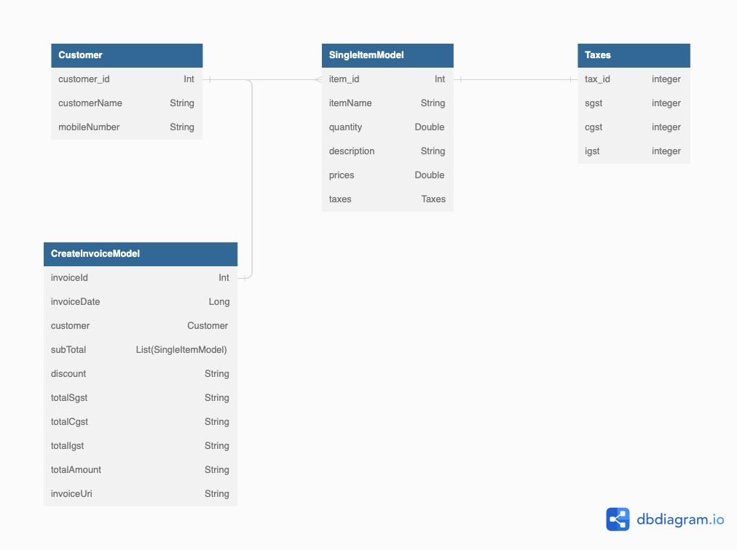This appendix includes the detailed database schema for the offline invoice generator. It provides a visual representation of the structure and relationships between different tables in the Room Database, including the profile_table and invoice_items table discussed in Chapter 3

Fig 11-1: Database Schema

## Appendix C: Code Snippets

This appendix presents relevant code snippets from the implementation of the offline invoice generator. It includes snippets of key functions, classes, or modules that demonstrate important aspects of the application's functionality or design. These code snippets can serve as a reference for developers or readers interested in exploring the implementation details.

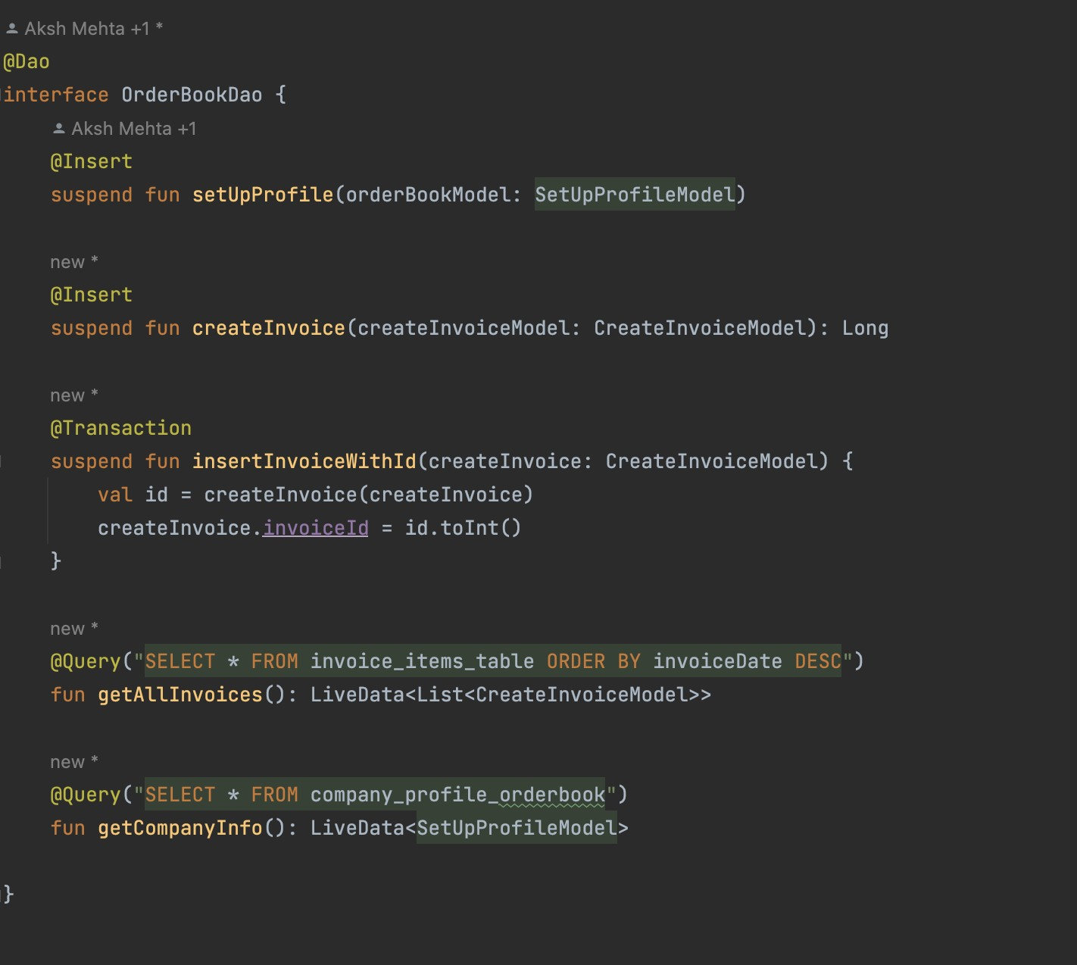

Fig 11-2: Dao Class

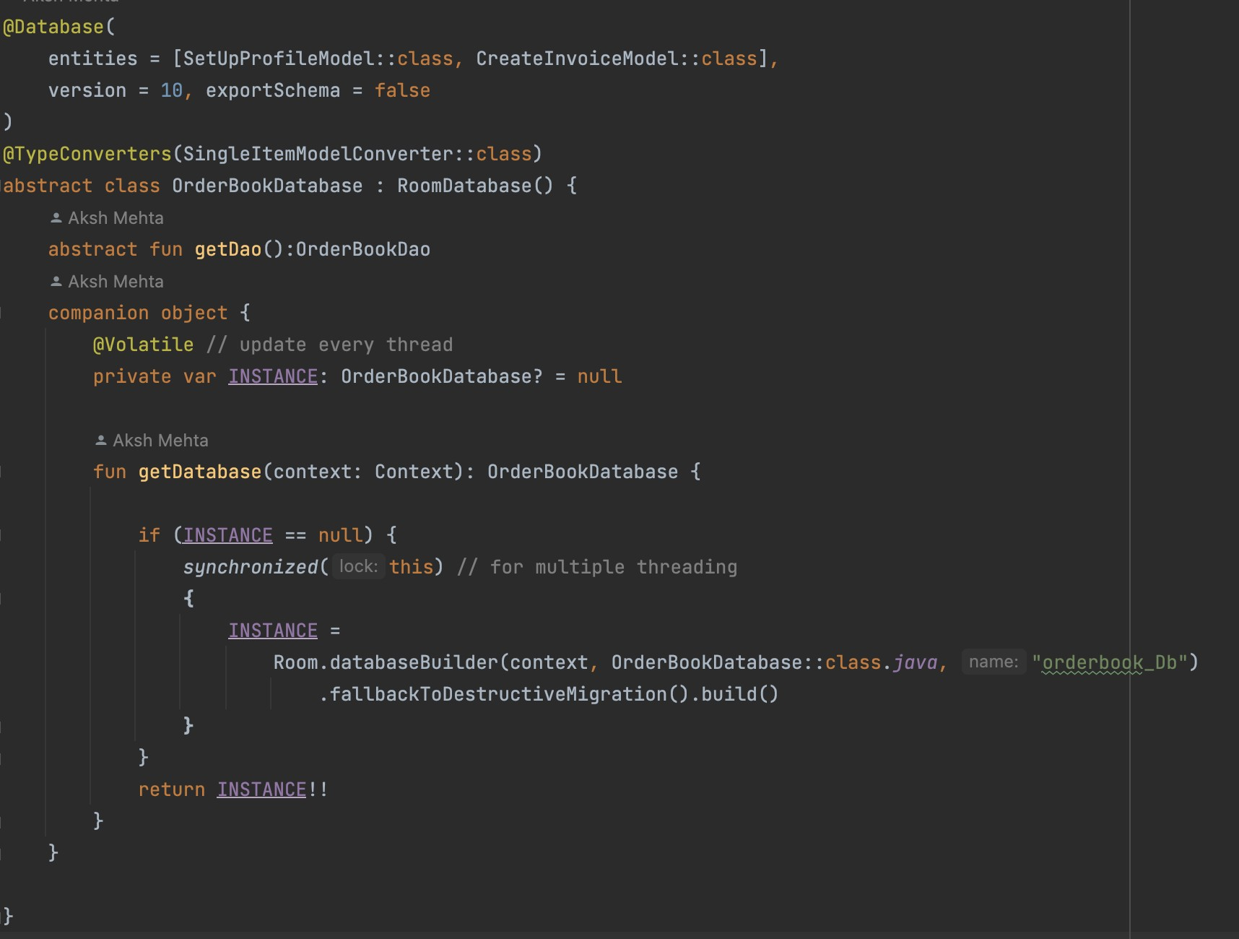

Fig 11-3: Database Initialization Class

## Appendix D: User Manual

The user manual appendix provides a comprehensive guide on how to use the offline invoice generator application. It includes step-by-step instructions, screenshots, and explanations of various features and functionalities. The user manual appendix is intended to help users, particularly small business owners or shopkeepers, navigate the application effectively and make the most out of its capabilities.

## Appendix E: Test Cases

This appendix contains a collection of test cases used during the testing phase of the offline invoice generator. It includes both positive and negative test scenarios to ensure thorough coverage of the application's functionality. Each test case provides a

description, expected result, and any relevant test data or prerequisites. The test cases appendix serves as a reference for future testing efforts or quality assurance activities.

## Appendix F: Sample Invoices

In this appendix, a selection of sample invoices generated by the offline invoice generator is included. These sample invoices showcase the layout, formatting, and information displayed in the generated invoices. The sample invoices appendix gives readers an idea of the visual representation and structure of the invoices produced by the application.



Fig 11-4 Sample Invoice 1 Fig 11-5 Sample Invoice 2